**Supporting File for Lab No. 5**

**Lab 5.1: Working with the cout Statement**

Fill in the code so that the program will do the following:

Write your first and last name on one line.

Write your address on the next line (recall the function of the endl statement).

Write your city, state and zip on the next line.

Write your telephone number on the next line.

Remember that to output a literal, such as “Hello”, you must use quotes.

Compile and run the program.

The code for name.cpp is as follows:

// This program will write the name, address and telephone

// number of the programmer.

// **PLACE YOUR NAME HERE**

#include <iostream> using namespace std;

int main()

{

// **Fill in this space to write your first and last name**

// **Fill in this space to write your address (on new line)**

// **Fill in this space to write you city, state and zip (on new line)**

// **Fill in this space to write your telephone number (on new line)**

return 0;

}

**LAB 5.2 Working with Constants, Variables and Arithmetic Operators**

Fill in the blanks and the cout statements so that the output will produce the following:

**The circumference of the circle is 33.912**

**The area of the circle is 91.5624**

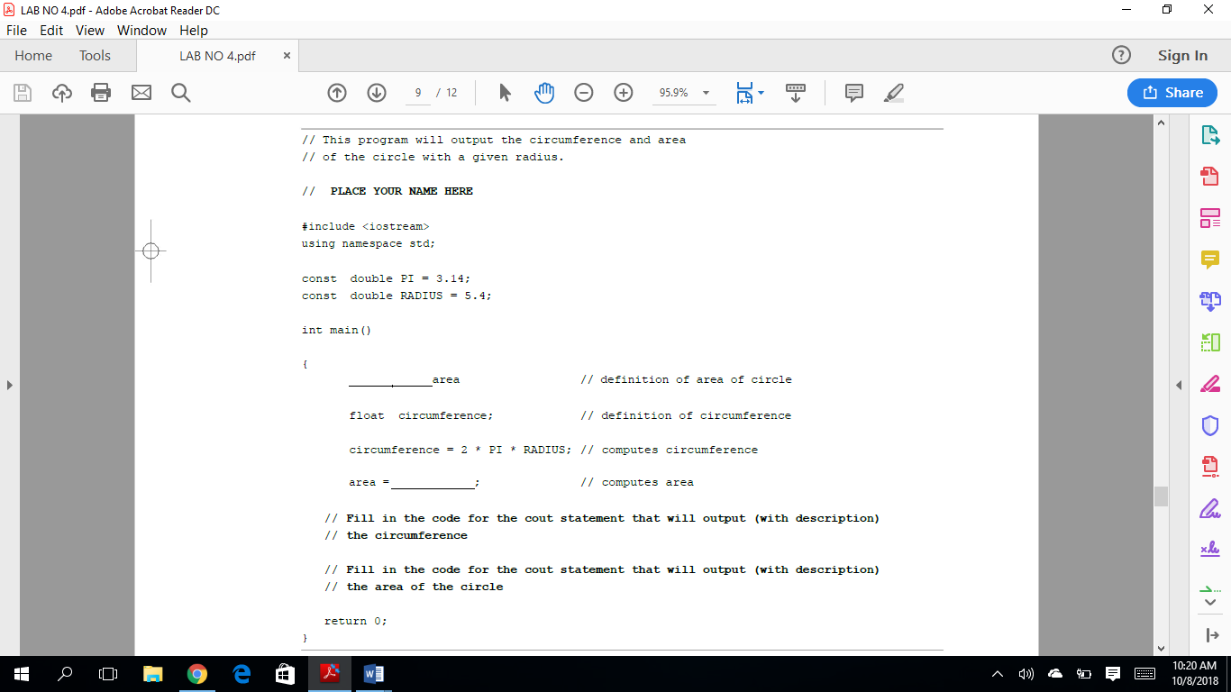

**LAB 5.3 Rectangle Area and Perimeter**

*Exercise 1:* Using Lab 5.2 as an example, develop a program that will deter-mine the area and perimeter of a rectangle. The length and width can be given as constants. (LENGTH=8 WIDTH=3)